Sensor Hub Driver Install SOP
1. Go to Windows device manager. Locate the sensor hub in the Device Manager under Human Interface Devices. It will be shown as ID-compliant device?with a hardware ID of VID_0483&PID_91D1&Col01.
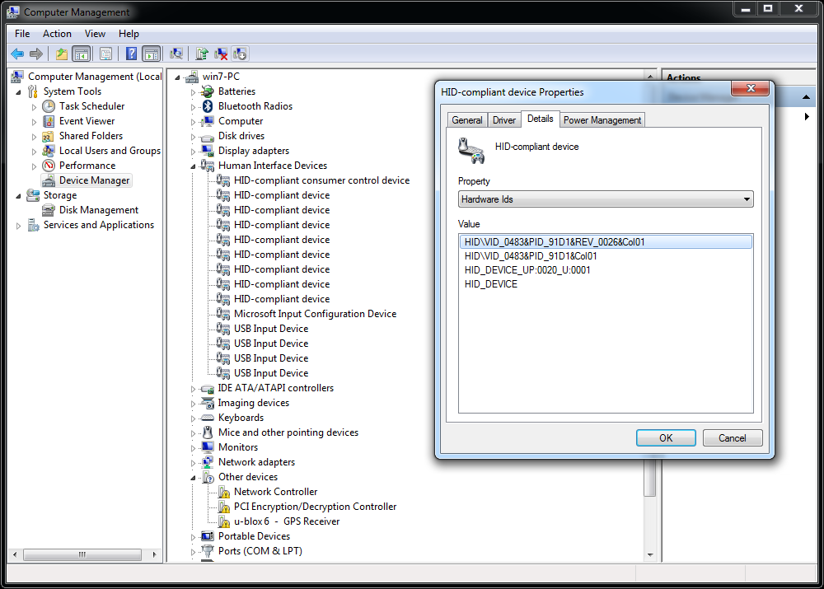
2. Right-click on the device and select Update Driver Software
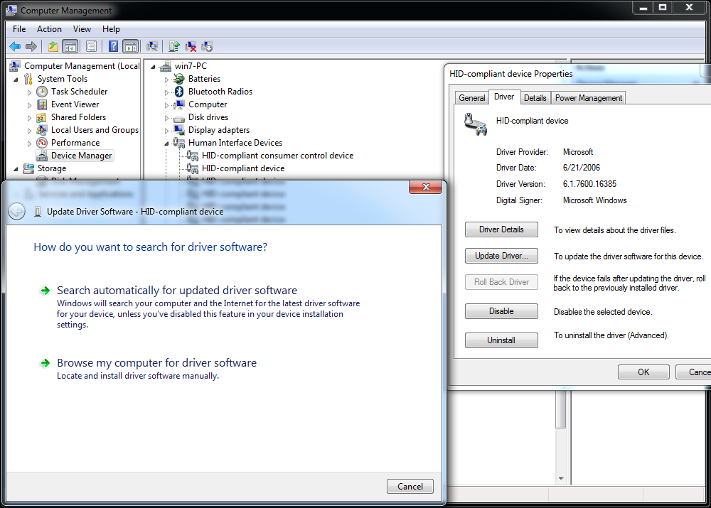

3. Select Browse my computer for driver software & Select Let me pick from a list of device drivers on my computer
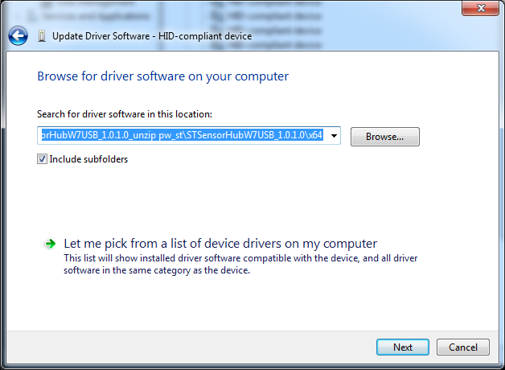
4. Select Have disk & Select Browse
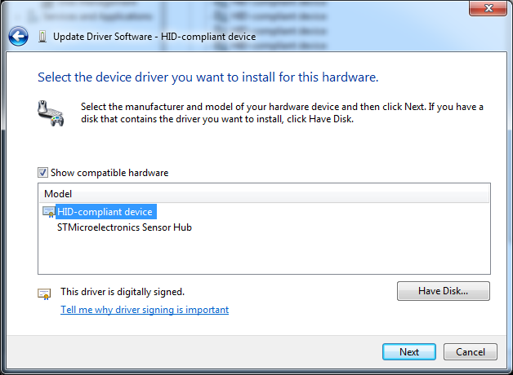

5. Navigate to the folder containing the drivers. Select the INF and click Open. Select OK. Select Next
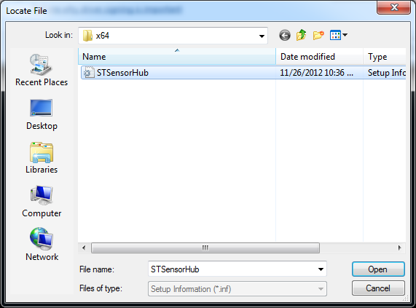
6. If a Windows security prompt appears, select Install this driver software anyway
The device should now appear in Device Manager under Sensors as STMicroelectronics Sensor Hub.
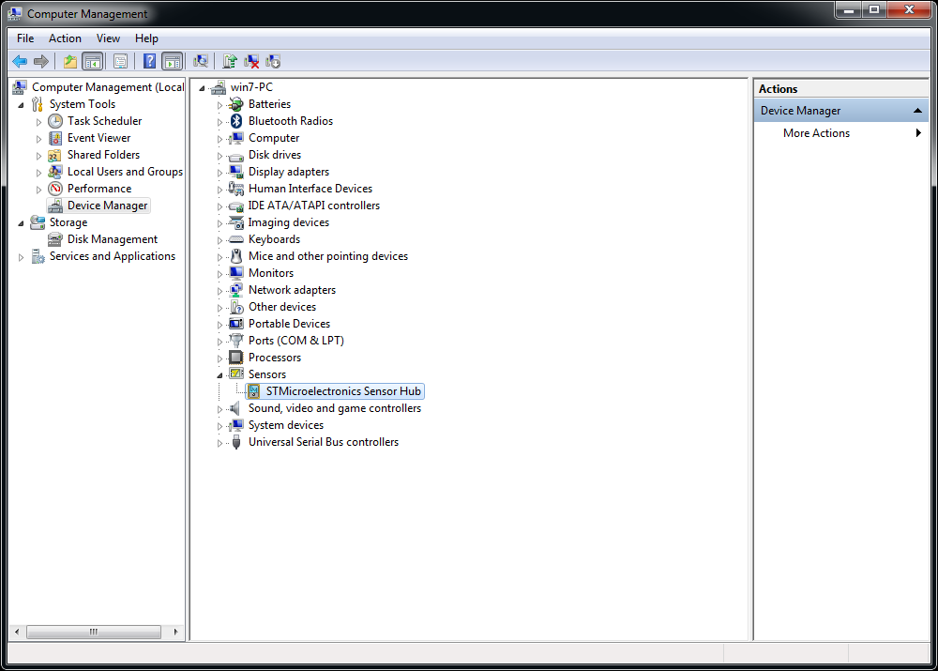

7. Go to Control Panel then enter Location and Other Sensors to enable sensor hub
